Smoke Detector

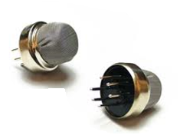

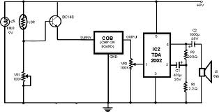

Two basic types of smoke detectors are used today: ionization and photoelectric. The sensing chambers of these detectors use different principles of operation to sense the visible or invisible particles of combustion given off in developing fires

Ionization Smoke Detector Operation:

A typical ionization chamber consists of two electrically charged plates and a radioactive source (typically Americium 241) for ionizing the air between the plates. The radioactive See Figure source emits particles that collide with the air molecules and dislodge their electrons. As the molecules lose electrons, they become positively charged ions. As other molecules gain electrons, they become negatively charged ions. Equal numbers of positive and negative ions are created. The positively charged ions are attracted to the negatively charged electrical plate, while the negatively charged ions are attracted to the positively charged plate. This creates a small ionization current that can be measured by electronic circuitry connected to the plates (“normal” condition in the detector).

Particles of combustion are much larger than the ionized air molecules. As particles of combustion enter an ionization chamber, ionized air molecules collide and combine with them. .) Some particles become positively charged and some become negatively charged. As these relatively large particles continue to combine with many other ions, they become recombination centers, and the total number of ionized particles in the chamber is reduced. This reduction in the ionized particles results in a decrease in the chamber current that is sensed by electronic circuitry monitoring the chamber. When the current is reduced by a predetermined amount, a threshold is crossed and an “alarm” condition is established.

Changes in humidity and atmospheric pressure affect the chamber current and create an effect similar to the effect of particles of combustion entering the sensing chamber. To compensate for the possible effects of humidity and pressure changes, the dual ionization chamber was developed and has become commonplace in the smoke detector market. A dual-chamber detector utilizes two ionization chambers; one is a sensing chamber, which is open to the outside air. The sensing chamber is affected by particulate matter, humidity, and atmospheric pressure. The other is a reference chamber, which is partially closed to outside air and is affected only by humidity and atmospheric pressure, because its tiny openings block the entry of larger particulate Matter including particles of combustion.

Electronic circuitry monitors both chambers and compares their outputs. If the humidity or the atmospheric pressure changes, the outputs of both chambers are affected equally and cancel each other. When combustion particles enter the sensing chamber, its current decreases while the current of the reference chamber remains unchanged. The resulting current imbalance is detected by the electronic circuitry. (See Figure 5.) There are a number of conditions that can affect dual-chamber ionization sensors such as dust, excessive humidity (condensation), significant air currents, and tiny insects. All of these can be misread as particles of combustion by the electronic circuitry monitoring the sensors.

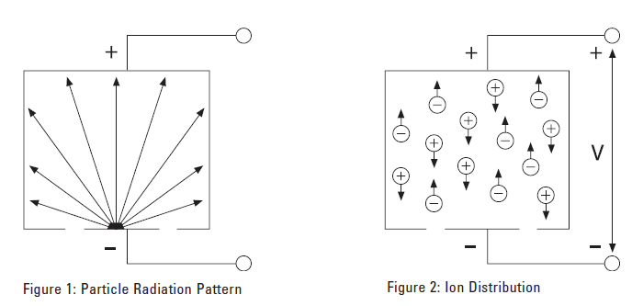

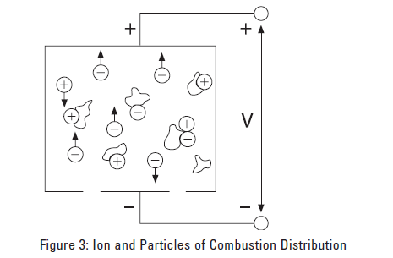

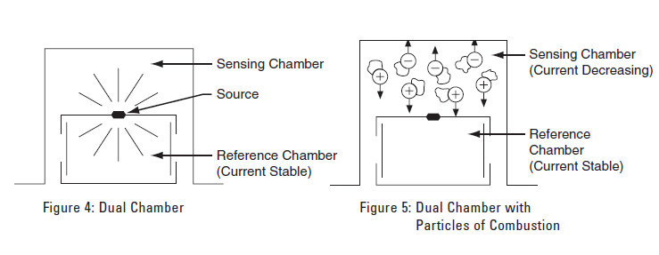

A smoke detector is a device that detects smoke, typically as an indicator of fire. Commercial, industrial, and mass residential devices issue a signal to a fire alarm system, while household detectors, known as smoke alarms, generally issue a local audible and/or visual alarm from the detector itself.
Smoke detectors are typically housed in a disk-shaped plastic enclosure about 150 millimeters (6 in) in diameter and 25 millimeters (1 in) thick, but the shape can vary by manufacturer or product line. Most smoke detectors work either by optical detection (photoelectric) or by physical process (ionization), while others use both detection methods to increase sensitivity to smoke. Sensitive alarms can be used to detect, and thus deter, smoking in areas where it is banned such as toilets and schools. Smoke detectors in large commercial, industrial, and residential buildings are usually powered by a central fire alarm system, which is powered by the building power with a battery backup. However, in many single family detached and smaller multiple family housings, a smoke alarm is often powered only by a single disposable battery.

Standalone smoke alarms
The main function of a standalone smoke alarm is to alert persons at risk. Several methods are used and documented in industry specifications published by Underwriters Laboratories Alerting methods include:
- Audible tones
  - Usually around 3200 Hz due to component constraints (Audio advancements for persons with hearing impairments have been made; see External links)
  - 85 dBA at 10 feet
- Spoken voice alert
- Visual strobe lights
  - 110 candela output
- Tactile stimulation, e.g., bed or pillow shaker (No standards exist as of 2008 for tactile stimulation alarm devices.)
Some models have a hush or temporary silence feature that allows silencing without removing the battery. This is especially useful in locations where false alarms can be relatively common (i.e. due to "toast burning") or users could remove the battery permanently to avoid the annoyance of false alarms, but removing the battery permanently is strongly discouraged.
While current technology is very effective at detecting smoke and fire conditions, the deaf and hard of hearing community has raised concerns about the effectiveness of the alerting function in awakening sleeping individuals in certain high risk groups such as the elderly, those with hearing loss and those who are intoxicated.[ Between 2005 and 2007, research sponsored by the United States National Fire Protection Association (NFPA) has focused on understanding the cause of a higher number of deaths seen in such high risk groups. Initial research into the effectiveness of the various alerting methods is sparse. Research findings suggest that a low frequency (520 Hz) square wave output is significantly more effective at awakening high risk individuals. Wireless WI-Safe smoke and carbon monoxide detectors linked to alert mechanisms such as vibrating pillow pads, strobes and remote warning handsets have been found to support the groups above.

